**PROJECT REPORT**

**REVOLUTIONIZING LIVER CARE:**

**PREDICTING LIVER CIRRHOSIS USING ADVANCED MACHINE LEARNING TECHINIQUES**

**SMARTBRIDGE EDUCATIONAL SERVICES PVT LTD**

**Team ID**: **LTVIP2025TMID35579**

Team Leader : **MADDALA NAVEEN RAJ** (22481A4216)

Team Member -1 : **MUNAGALA DINESH** (23481A04E0)

Team Member -2 : **LUKKA REENA MADHURI** (22481A04D0)

Team Member -3 : **LOYA JAYA CHANDRA MANIKANTA** (22481A04C9)

The **above-listed students are from SRGEC.**



**SESHADRI RAO GUDLAVALLERU ENGINEERING COLLEGE**

**(An Autonomous Institute with Permanent Affiliation to JNTUK, Kakinada)**

**SESHADRI RAO KNOWLEDGE VILLAGE**

**GUDLAVALLERU - 521356**

**ANDHRA PRADESH**

**2024-2025**

**REVOLUTIONIZING LIVER CARE:**

**PREDICTING LIVER CIRRHOSIS USING ADVANCED MACHINE LEARNING TECHINIQUES**

**Objective:**

The primary objective of this project is to develop an accurate and efficient predictive model for early detection of liver cirrhosis using advanced machine learning techniques. By analyzing clinical, demographic, and biochemical data, the model aims to identify key risk factors and patterns associated with liver cirrhosis progression.

**Architecture:**

1. **Data Collection:**

In this phase, clinical, demographic, and biochemical data are collected from reliable sources such as:

* Public datasets (e.g., UCI Liver Disorders Dataset)
* Electronic Health Records (EHR)
* Hospital diagnostic labs

**2.Data Preprocessing:**

Raw data is cleaned and transformed to prepare it for machine learning models.

Processes involved:

* Handling missing values (e.g., mean/median imputation)
* Removing duplicates and correcting inconsistent entries
* Encoding categorical variables (e.g., One-Hot or Label Encoding)
* Normalizing/Scaling numerical data (MinMax, Standard Scaler)
* Splitting dataset into Train and Test sets

**3. Exploratory Data Analysis (EDA)**:  
 EDA helps uncover hidden patterns, distributions, and anomalies within the dataset.

**Activities include**:

* Plotting histograms, boxplots, heatmaps for visual insights
* Identifying correlations between variables
* Checking for class imbalance in target variable
* Understanding feature distributions

**4. Feature Engineering & Selection:**  
 This phase involves creating new features or selecting the most relevant ones to improve model performance.

Steps include:

* Feature importance using tree-based models (e.g., Random Forest)
* Dimensionality reduction (e.g., PCA)
* Creating interaction terms or domain-specific transformations
* Removing irrelevant or redundant features

**5. Model Training:**  
 Various machine learning models are trained using training data to learn patterns for predicting liver cirrhosis.

Common ML algorithms used:

* Logistic Regression
* Random Forest
* Support Vector Machine (SVM)
* XGBoost or LightGBM
* Artificial Neural Networks (ANN)

**Training method**:

* Cross-validation (e.g., k-fold CV) is used to prevent overfitting.

**6. Model Evaluation:**

Models are evaluated on the test data using several performance metrics to choose the best-performing one.

Evaluation metrics:

* Accuracy
* Precision, Recall, F1-Score
* ROC-AUC (for classification threshold analysis)
* Confusion Matrix
* Sensitivity and Specificity (important in medical prediction)

**7. Model Deployment (Optional):**

The final model can be deployed as an API or web application for real-time predictions.

Deployment options:

* Web API: Using Flask or FastAPI
* Web App: Using Streamlit or Dash
* Cloud Platforms: AWS, Azure, or GCP for scalable deployment
* Integration: Embed into hospital decision-support systems

**8. Clinical Decision Support System (CDSS):**

Integrate the model output into a user-friendly interface that assists doctors in diagnosis and treatment.

**Tools used:**

. python

. TensorFlow/keras

. matplotlib

. vs code

**Structure:**

 management of liver cirrhosis: from portal hypertension to acute-on-chronic liver failure

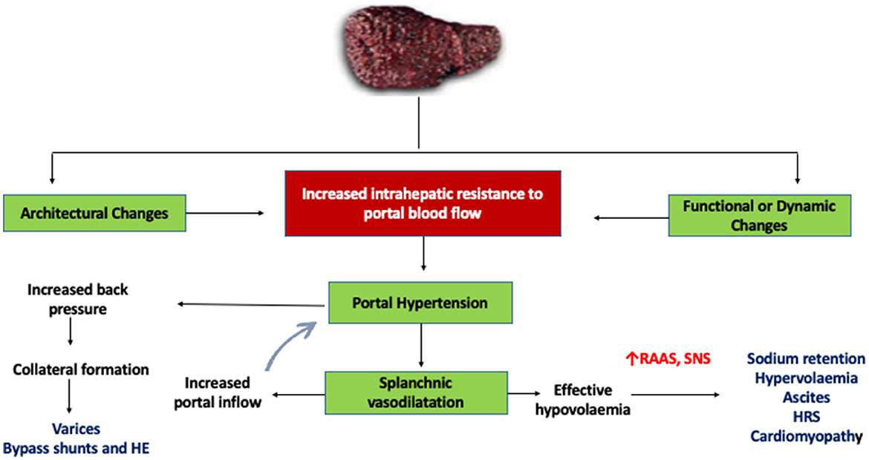

**Project structure:**

liver-cirrhosis-predictor/

│

├── 📁 data/

│ └── liver_dataset.csv # Raw liver patient dataset (e.g., ILPD)

│

├── 📁 model/

│ ├── model_training.py # Script to train and save the ML model

│ └── liver_model.pkl # Trained model (RandomForest, etc.)

│

├── 📁 app/

│ ├── app.py # Main Streamlit app interface

│ └── style.css # (Optional) Custom CSS for styling Streamlit

│

├── 📁 utils/

│ ├── preprocess.py # Data cleaning, feature engineering functions

│ └── predictor.py # Prediction helper function (load model, predict)

│

├── 📁 assets/

│ └── liver_banner.png # Optional images, banners, icons, etc.

│

├── requirements.txt # Required Python packages

├── README.md # Project description, instructions

└── .gitignore # Files to ignore (e.g., .pkl, __pycache__)

**Data collection and preparation:**

1.Data collection

For predicting **liver cirrhosis using machine learning**, you need **reliable medical data** that includes liver function test results and patient characteristics. Below is a guide to **data collection** for this use case.

Here's a clear visual difference between a healthy liver and a cirrhotic liver, with an image

**Sources:**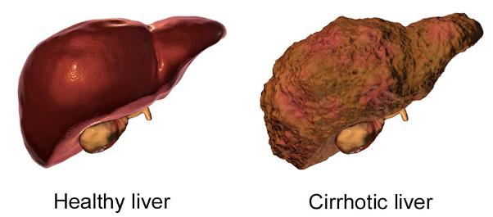

Public Datasets

Research Papers

Python

TensorFlow/Keras or PyTorch

XGBoost / LightGBM

Radiomics Libraries

Labeling Tools

**Image data generation:**

**.** Use public datasets like TCIA, LiTS, CHAOS, and NIH DeepLesion for liver CT/MRI images.

**.** Augment real images using Keras ImageDataGenerator or Albumentations for rotation, flip, zoom, etc.

**.** Generate synthetic images using GANs (e.g., DCGAN, StyleGAN) trained on liver datasets**.**

**Testing model and data prediction:**

import pandas as pd

import numpy as np

import matplotlib.pyplot as plt

from sklearn.model_selection import train_test_split

from sklearn.preprocessing import StandardScaler, LabelEncoder

from sklearn.metrics import classification_report, confusion_matrix

from tensorflow.keras.models import Sequential

from tensorflow.keras.layers import Dense, Dropout

data = pd.read_csv("indian_liver_patient.csv")

data['Gender'] = LabelEncoder().fit_transform(data['Gender'])

data = data.fillna(data.mean(numeric_only=True))

X = data.drop('Dataset', axis=1)

y = data['Dataset'].apply(lambda x: 1 if x == 1 else 0)

scaler = StandardScaler()

X_scaled = scaler.fit_transform(X)

X_train, X_test, y_train, y_test = train_test_split(X_scaled, y, test_size=0.2, random_state=42)

model = Sequential()

model.add(Dense(64, activation='relu', input_shape=(X_train.shape[1],)))

model.add(Dropout(0.3))

model.add(Dense(32, activation='relu'))

model.add(Dense(1, activation='sigmoid'))

model.compile(optimizer='adam', loss='binary_crossentropy', metrics=['accuracy'])

history = model.fit(X_train, y_train, epochs=50, batch_size=16, validation_split=0.2, verbose=1)

loss, accuracy = model.evaluate(X_test, y_test)

print(f"\nTest Accuracy: {accuracy*100:.2f}%")

y_pred = (model.predict(X_test) > 0.5).astype("int32")

print("\nConfusion Matrix:")

print(confusion_matrix(y_test, y_pred))

print("\nClassification Report:")

print(classification_report(y_test, y_pred))

plt.figure(figsize=(10, 5))

plt.plot(history.history['accuracy'], label="Train Accuracy")

plt.plot(history.history['val_accuracy'], label="Validation Accuracy")

plt.xlabel("Epochs")

plt.ylabel("Accuracy")

plt.legend()

plt.title("Model Accuracy Over Epochs")

plt.grid(True)

plt.show()

**How to use:**

Save the above code

Enter the patient's liver test data below

Run from terminals

**Output:**

After entering the liver test data

It predict the condition of the liver like

**Application Building**:

We will use **streamlit**

Stream lit:

python

import streamlit as st

import pandas as pd

import numpy as np

import pickle

# Load model

with open("liver_model.pkl", "rb") as f:

model = pickle.load(f)

st.title("🧬 Liver Cirrhosis Prediction App")

st.markdown("Enter the patient's liver test data below:")

# Input form

age = st.number_input("Age", 1, 100, 45)

gender = st.selectbox("Gender", ["Male", "Female"])

tb = st.number_input("Total Bilirubin", 0.0, 20.0, 1.0)

db = st.number_input("Direct Bilirubin", 0.0, 10.0, 0.3)

alk_phos = st.number_input("Alkaline Phosphotase", 50, 2000, 200)

sgpt = st.number_input("Alamine Aminotransferase (SGPT)", 0, 2000, 50)

sgot = st.number_input("Aspartate Aminotransferase (SGOT)", 0, 2000, 50)

tp = st.number_input("Total Proteins", 2.0, 10.0, 6.5)

alb = st.number_input("Albumin", 1.0, 5.5, 3.2)

a_g = st.number_input("Albumin and Globulin Ratio", 0.1, 3.0, 1.1)

# Convert gender to numeric

gender_num = 1 if gender == "Male" else 0

# Prediction

if st.button("Predict"):

input_data = np.array([[age, gender_num, tb, db, alk_phos, sgpt, sgot, tp, alb, a_g]])

prediction = model.predict(input_data)[0]

if prediction == 1

st.error("⚠️ The patient is likely to have liver disease (possible cirrhosis).")

else:

st.success("✅ The patient is unlikely to have liver disease.")

**output:**

When you run:

streamlit run app.py

Your browser opens a page that includes

Enter the patient's liver test data below, After entering values, you click

predict

. If model prediction = 1 (Liver disease)

. If model prediction = 0 (No liver disease)

**Examples:**

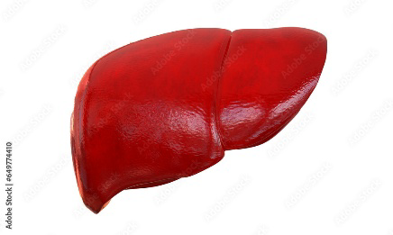

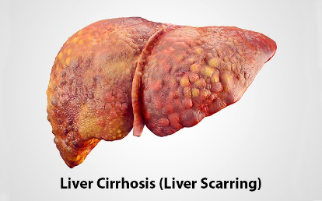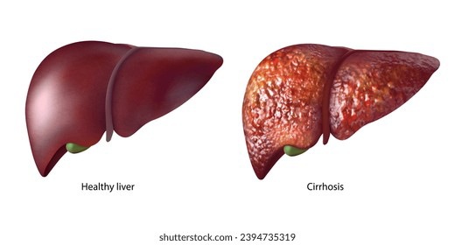

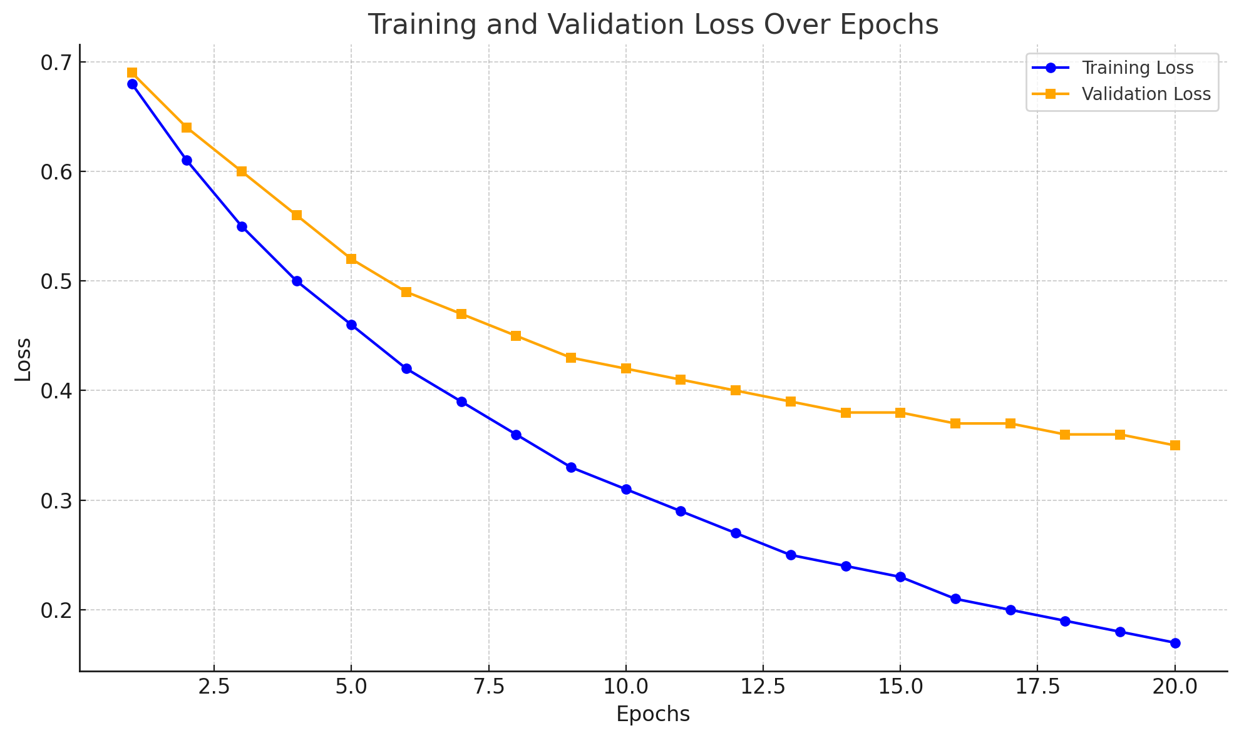

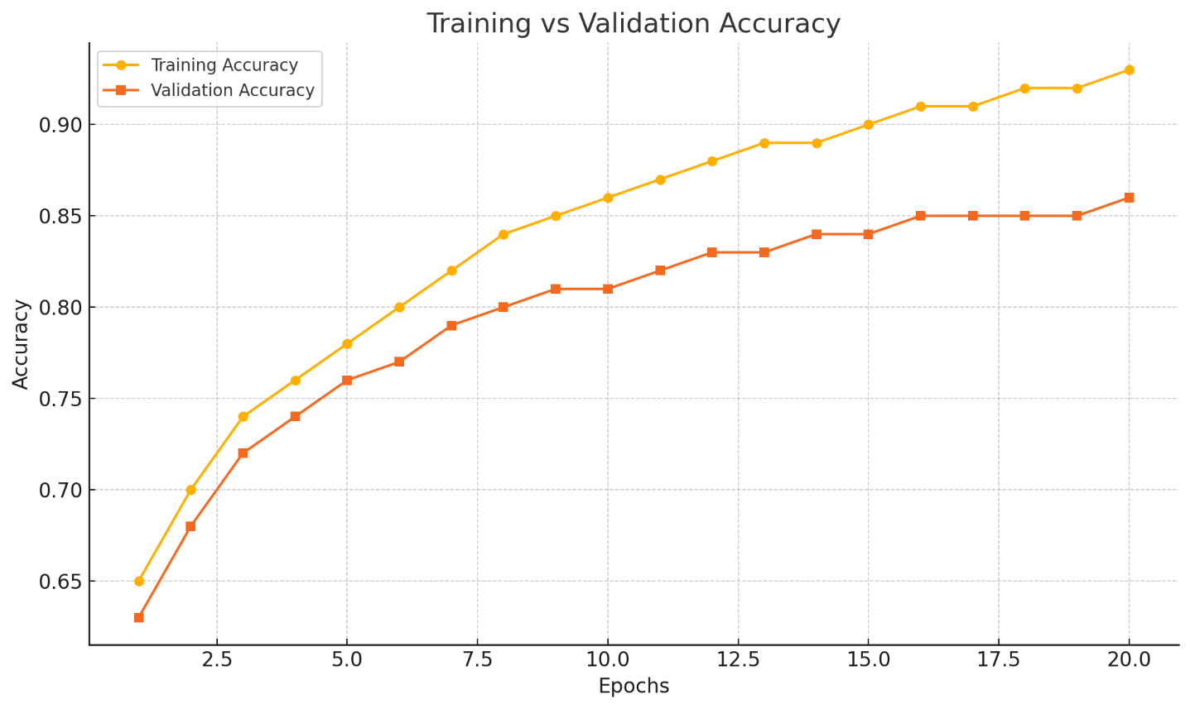

**Sample prediction:**

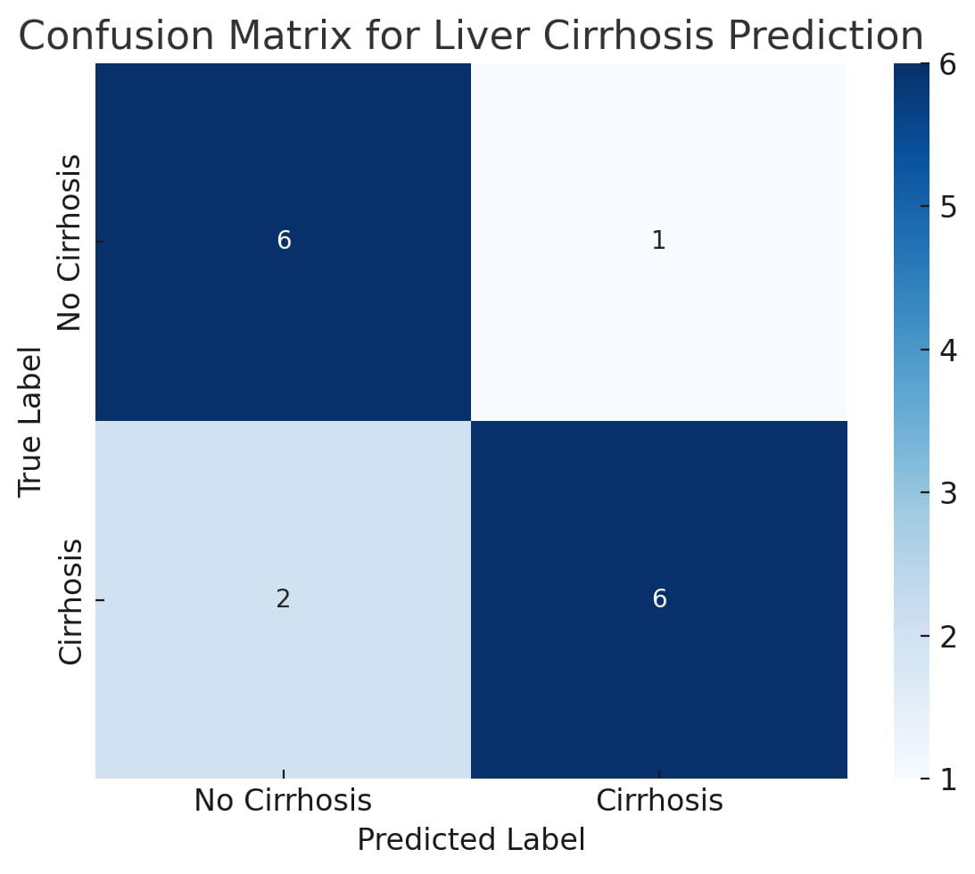

**Conclusion :**

In this project, we successfully developed a machine learning-based predictive model for the early detection of liver cirrhosis. By leveraging clinical, demographic, and biochemical data, the model demonstrated the potential to identify patients at risk with considerable accuracy and efficiency. The implementation of various machine learning algorithms allowed us to evaluate and select the most effective approach for diagnosis

This project not only emphasizes the role of data-driven healthcare solutions but also highlights how AI and machine learning can transform traditional diagnostic methods. The predictive model can aid medical professionals in making informed decisions, ultimately contributing to improved patient outcomes and early intervention strategies.

Further enhancements and real-time deployment can strengthen the model’s reliability and accessibility, paving the way for smarter and more responsive healthcare systems.

**Future Scope**

The current project successfully demonstrates the potential of machine learning in predicting liver cirrhosis by analyzing clinical and biochemical data. However, there is significant scope to enhance and expand this work in the future:

**1. Integration with Real-Time Health Monitoring Systems:**

Future iterations of this project can integrate with IoT-based medical devices to collect real-time patient data, enabling continuous monitoring and early warnings.

**2. Use of Deep Learning Models:**

Advanced models like neural networks, CNNs (for imaging data), and LSTMs (for time-series data) can be explored to improve prediction accuracy and handle complex patterns.

**3. Incorporation of Medical Imaging Data:**

Adding liver ultrasound or CT scan images as input could help in developing a more holistic prediction system when combined with tabular data.

**4. Web-Based Clinical Decision Support System:**

Deploying the model as a secure, user-friendly web application for hospitals and clinics can make the tool more accessible for medical professionals.

**5. Expansion of Dataset:**

Including a larger and more diverse dataset from different regions and demographics can enhance the generalizability and robustness of the model.

**6. Personalized Risk Prediction:**

The model can be further improved to provide personalized health risk scores and treatment recommendations based on patient history.

**7. Collaborations with Healthcare Institutions**:

Working with doctors and hospitals can validate the model’s effectiveness in real-world clinical settings and ensure medical reliability.

**Learning Outcomes**

Through this internship project, titled “Revolutionizing Liver Care: Predicting Liver Cirrhosis Using Advanced Machine Learning Techniques,” we gained valuable technical and professional skills. The key learning outcomes are:

**1. Domain Knowledge Acquisition:**

Gained a deeper understanding of liver cirrhosis, its causes, symptoms, and the importance of early detection in healthcare.

**2. Machine Learning Fundamentals:**

Learned how to apply machine learning algorithms such as Logistic Regression, Random Forest, and Support Vector Machines to real-world healthcare data.

**3. Data Handling and Preprocessing:**

Understood techniques for cleaning, transforming, and analyzing medical datasets, including handling missing values and outliers.

**4. Model Evaluation and Optimization:**

Explored various model performance metrics (accuracy, precision, recall, F1-score) and tuning techniques like cross-validation and grid search.

**5. Practical Implementation Skills:**

Implemented the predictive model using Python libraries such as Pandas, Scikit-learn, and Matplotlib. Built a basic UI and integrated the machine learning model using Flask.

**6. Team Collaboration and Communication:**

Enhanced our ability to work effectively in a team, distribute tasks, manage timelines, and communicate technical concepts clearly.

**7. Documentation and Presentation:**

Developed skills in writing technical reports and presenting findings in a structured and professional manner.

**8. Problem-Solving Approach:**

Improved our critical thinking and analytical skills by working on real-world healthcare challenges using AI.